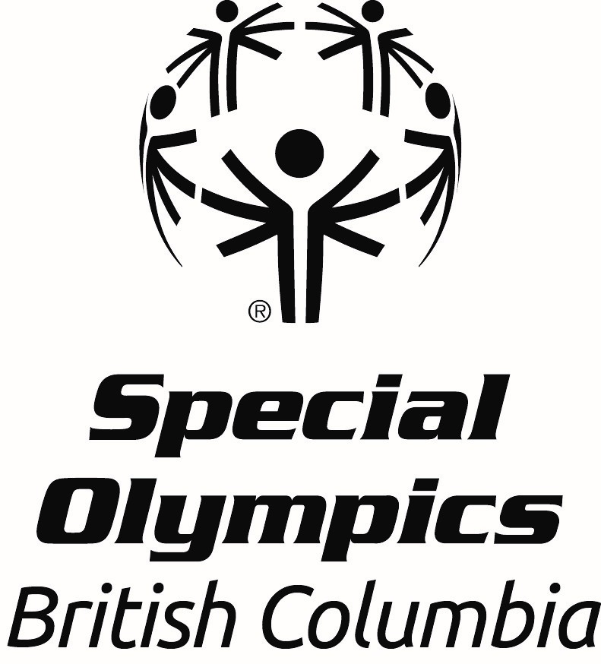

Howard Carter Award
Nomination Form
Office Use Only
Date received:

All nominations must be received by April 19th 2026.

Howard Carter was an upstanding member of the automobile business community and a great friend of Special Olympics BC. Mr. Carter recognized the value of coaches and as such, this award is presented in his memory. The winner of the Howard Carter Award is a coach who provides exceptional training to the athletes and ensures that they are prepared to beat their personal bests and deliver high caliber performances at competitions. This coach is a creative problem solver and is always creating new ways to improve strength and conditioning in his/her athletes.

PLEASE NOTE: To be eligible for the Howard Carter Award, the nominee must have travelled to at least one Special Olympics National Games; the ideal candidate will have travelled to more than one Special Olympics National Games and one or more Special Olympics World Games.

Nomination forms must be completed in full to be considered and be endorsed by the local. Please type or print in block letters and include the names and contact information for two references. In addition to the nomination form, please send a photo of the nominee to awards@specialolympics.bc.ca or submit it to our dropbox linked here.

*An email confirmation will be sent within 3 business days of receiving the nomination; if you do not get this email, please contact Leanne Ficocelli, Community Development Coordinator, 778-581-0511
Nominee Information:
Name:
Volunteer’s Pronouns: she/her/hers he/him/his they/them/theirs
Local:
Email Address:
Home Address:
City:
Postal Code:
Telephone:
Please answer the following questions using concrete examples where possible. This information will be evaluated during the selection process.

- How many years has the coach been involved in Special Olympics in BC?

- What sport program is this coach responsible for and what role do they perform (Head or Assistant)?

- Has this coach been to National Games? If yes, please include when they went to National Games.
Yes
No

- Has this coach been to World Games? If yes, please include when they went to World Games.
Yes
No

- Please provide two specific examples of how this coach has encouraged or assisted athletes and other coaches/volunteers to develop new skills.

- Does this coach show a willingness to improve their education or coaching skills? If so, please list any coaching courses/certifications/seminars the coach has attended within sport (i.e. Special Olympics Coach Development Workshops, NCCP Course, etc). Please include the coach’s NCCP number if possible.

- Describe the coach’s interactions and relationships with athletes, fellow coaches and parents/caregivers.

- How has this coach demonstrated leadership in their sport? Please provide one or two specific examples.

- How has this coach encouraged the overall development of the athletes (for example, teaching nutrition or how to improve self-esteem)?

- Please provide two specific examples of how this coach supported an athlete or team to improve significantly or achieve a goal.

References:

Name:
Relationship to Coach:
Email Address:
Phone Number:

Name:
Relationship to Coach:
Email Address:
Phone Number:

Endorsement by Local (Coordinator):
Name:

**Prior to publicly announcing the award winners, the Local will be contacted to arrange an awards presentation for the successful nominee.

Please submit completed nomination forms and photo to awards@specialolympics.bc.ca or by mail to:

ATTN: Awards Committee
210 – 3701 Hastings St., Burnaby BC
V5C 2H6

DEADLINE FOR SUBMISSIONS is April 19th, 2026.

