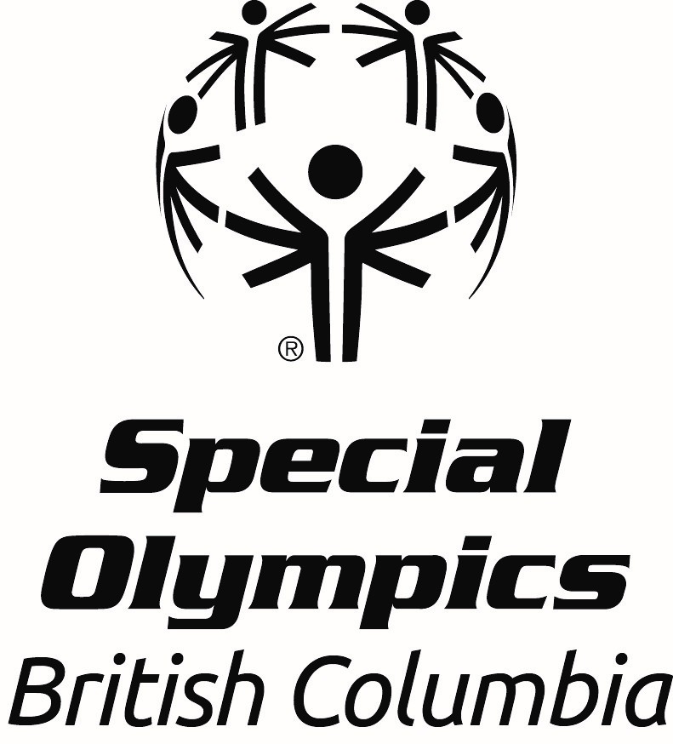
Office Use Only
Date received:

Athletic Achievement Award
Nomination Form

All nominations must be received by April 19th 2026.

This award is presented annually to an athlete who has demonstrated outstanding athletic skill both in practice and competition. This athlete works hard to develop their abilities and to excel in their sport(s). In addition to athletic ability, this athlete consistently acts as a role model for other Special Olympics athletes. It is preferred that the nominee has travelled to at least one Special Olympics National Games; the ideal candidate will have travelled to more than one Special Olympics National Games and one or more Special Olympics World Games.

Nomination forms must be completed in full to be considered and be endorsed by the local. Please type or print in block letters and include the names and contact information for two references. In addition to the nomination form, please send a photo of the nominee to awards@specialolympics.bc.ca or submit it to our dropbox linked here.

*An email confirmation will be sent within 3 business days of receiving the nomination; if you do not get this email, please contact Leanne Ficocelli, Community Development Coordinator, 778-581-0511

Nominee Information:

Name:
Athlete’s Pronouns: she/her/hers he/him/his they/them/theirs
Local:
Email Address of Athlete or Caregiver:
Home Address:
City:
Postal Code:
Telephone:

Please answer the following questions using concrete examples where possible. This information will be evaluated during the selection process.

- How many years has the individual been involved in Special Olympics in BC?

- What sport program(s) is the athlete registered in?

- Has this athlete been to National Games? If yes, please include when they went to National Games.
Yes
No

- Has this athlete been to World Games? If yes, please include when they went to World Games.
Yes
No

- What are two examples of how this athlete has achieved their personal best or realized their athletic goals (for example, becoming a member of TEAM BC; setting personal bests at every competition)?

- How does the athlete show they are a role model?

- How has the athlete demonstrated improvement in their sport specific skill? (Please include times, distances, and/or scores if available)

- How has the athlete displayed personal growth and development (for example, self-discipline or independence)?

- Provide a specific example of a time this athlete shown sportsmanship towards other Special Olympics Athletes, Coaches, and/or Officials.

References:

Name:
Relationship to Athlete or Volunteer Role:
Email Address:
Phone Number:

Name:
Relationship to Athlete or Volunteer Role:
Email Address:
Phone Number:

Endorsement by Local (Coordinator):
Name:

**Prior to publicly announcing the award winners, the Local will be contacted to arrange an awards presentation for the successful nominee.

Please submit completed nomination form and photo to awards@specialolympics.bc.ca or mail to:

ATTN: Awards Committee
210 – 3701 Hastings St., Burnaby BC
V5C 2H6

DEADLINE FOR SUBMISSIONS is April 19th, 2026.

