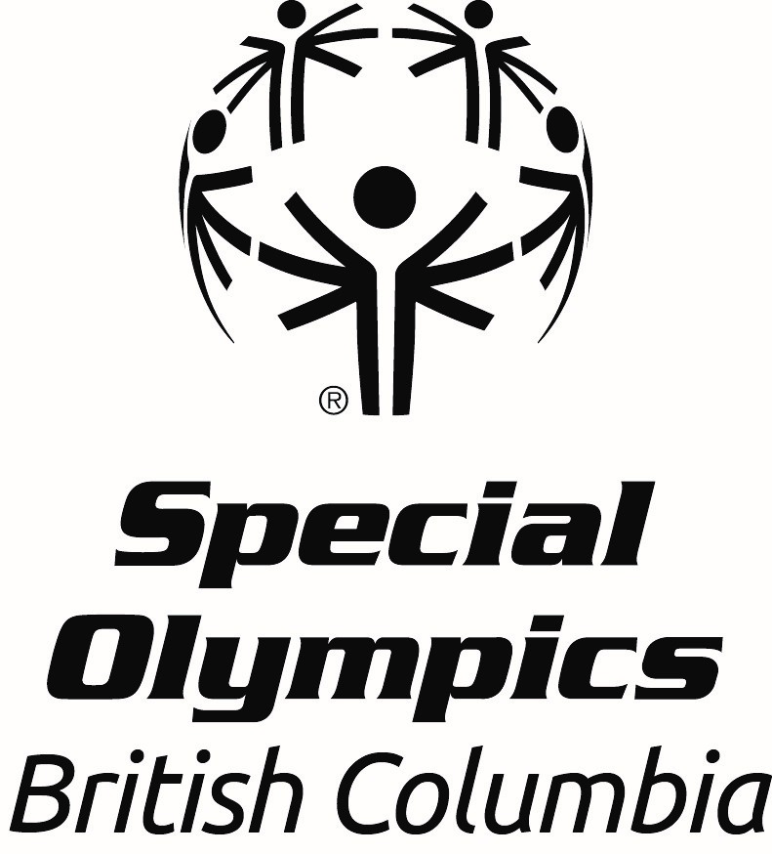
Office Use Only
Date received:

Spirit of Sport Award
Nomination Form

All nominations must be received by April 19th 2026.

This award is presented annually to an athlete who exemplifies the true meaning of sportsmanship. The athlete’s oath states ‘let me win and if I cannot win, let me be brave in the attempt’. This athlete lives by our athlete’s oath and is an inspiration to fellow athletes and coaches. This athlete shows dedication, enthusiasm and always gives their best effort.

Nomination forms must be completed in full to be considered and be endorsed by the local. Please type or print in block letters and include the names and contact information for two references. In addition to the nomination form, please send a photo of the nominee to awards@specialolympics.bc.ca or submit it to our dropbox linked here.

*An email confirmation will be sent within 3 business days of receiving the nomination; if you do not get this email please contact Leanne Ficocelli, Community Development Coordinator, 778-581-0511

Nominee Information:

Name:
Athlete’s Pronouns: she/her/hers he/him/his they/them/theirs
Local:
Email Address of Athlete or Caregiver:
Home Address:
City:
Postal Code:
Telephone:

Please answer the following questions using concrete examples where possible. This information will be evaluated during the selection process.

- How many years has the athlete been involved in Special Olympics in BC?

- What sport program(s) is the athlete registered in?

- Does the athlete have any other roles within your Local (for example, Athlete Representative or Athlete Speaker)?

- What are two examples of how this athlete has demonstrated sportsmanship and dedication to Special Olympics BC?

- Please describe the athlete’s interactions and relationships with fellow teammates, coaches and other members of the community (for example, friends, family, employers).

References:

Name:
Relationship to Athlete and/or Volunteer Role:
Email Address:
Phone Number:

Name:
Relationship to Athlete and/or Volunteer Role:
Email Address:
Phone Number:

Endorsement by Local (Coordinator):
Name:

**Prior to publicly announcing the award winners, the Local will be contacted to arrange an awards presentation for the successful nominee.

Please submit completed nomination forms and a photo to awards@specialolympics.bc.ca or by mail to:

ATTN: Awards Committee
210 – 3701 Hastings St., Burnaby BC
V5C 2H6

DEADLINE FOR SUBMISSIONS is April 19th, 2026.

