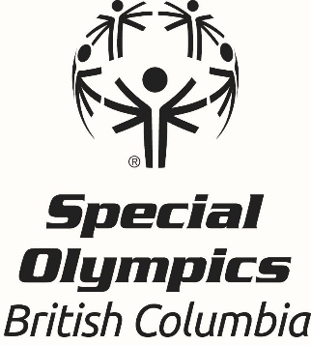

Coach Ambition Award
Office Use Only
Date received:
Nomination Form

All nominations must be received by April 19th 2026.

This award recognizes a coach who contributes to the overall organization, promotion, and development of sport in Special Olympics. The coach demonstrates potential to create a significant and positive impact through their Special Olympics coaching role in the future. They are a positive role model for athletes and other coaches, providing stable and consistent leadership qualities. The coach practices co-operation, self-discipline and respect for officials and opponents.

To be eligible for this award, the coach must be a registered Special Olympics coach (assistant or head coach) under the age of 25 and must have been a Special Olympics coach for less than 5 years. Additional years as an operational/non-coaching volunteer do not count towards the 5 years as a registered coach.

Nomination forms must be completed in full to be considered and be endorsed by the local. Please type or print in block letters and include the names and contact information for two references. In addition to the nomination form, please send a photo of the nominee to awards@specialolympics.bc.ca or submit it to our dropbox linked here.

*An email confirmation will be sent within 3 business days of receiving the nomination; if you do not get this email, please contact Leanne Ficocelli, Community Development Coordinator, 778-581-0511

Nominee Information:
Name:
Volunteer’s Pronouns: she/her/hers he/him/his they/them/theirs
Local:
Email Address:
Home Address:
City:
Postal Code:
Telephone:

Please answer the following questions using concrete examples where possible. This information will be evaluated during the selection process

- How many years has the coach been involved in Special Olympics in BC?

- What sport program is this coach responsible for and what role do they perform (Head or Assistant)? Please list the responsibilities of this position and any other duties the coach performs.

- Does this coach show a willingness to improve their education or coaching skills? If so, please list any coaching courses/certifications/seminars the coach has attended within sport (i.e. Special Olympics Coach Development Workshops, NCCP Course, etc).

- How has this coach progressed/developed as a coach since getting involved with Special Olympics BC?

- Please specify the coach's involvement in the organization or initiation of programs and or competitions including sport committees, boards and or/associations within the past year (2024-2025 season). Provide the term of office and list the responsibilities of the coach.

- What is the future potential of this individual as a Special Olympics coach? Please provides specific examples that give you confidence in their ability to create a lasting impact at Special Olympics.

- How has the coach's athlete(s)/team(s) demonstrated improvement within the 2024-2025 season(s)? Provide specific examples of athlete/team improvement and achievement of goals.

- Please provide an example of how the coach has been a positive role model for their athlete(s) and other coaches.

References:

Name:
Relationship to Coach:
Email Address:
Phone Number:

Name:
Relationship to Coach:
Email Address:
Phone Number:

Endorsement by Local (Coordinator):
Name:

**Prior to publicly announcing the award winners, the Local will be contacted to arrange an awards presentation for the successful nominee.

Please submit completed nomination forms to awards@specialolympics.bc.ca or by mail to:

ATTN: Awards Committee
210 – 3701 Hastings St., Burnaby BC
V5C 2H6

DEADLINE FOR SUBMISSIONS is April 19th 2026.

